# TASK:4

Implementation of **Mini-Max algorithm** using recursion to search through the Game - tree using python by applying following constraints.

**Aim:** To create a program for searching problem using Mini-max algorithm with Alpha-Beta pruning approach.

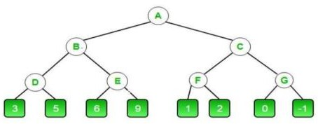

# Algorithm:

**Step 1:** At the first stop the, Max player will start first move from node A where α=-infinity and beta = +infinity, these values of alpha and beta passed down to node B. Node B transmitting the identical value to its off spring D.

**Step2:** As Max's turn at Node D approaches, the value of α will be decided. when the value of α is compared to 3 then 5 the value at node D is max (3,5) = 5. Hence the node value is also 5

**Step 3:** The algorithm returns to node B, where the value of beta will change since this a turn of min

**Step 4:** Max will take over at node E and change alpha's value.

**Step 5:** We know traverse the tree backward, from node B to node A

**Step 6:** As a result, in this case, the ideal value for the maximizer is 5.

# Program:

# # Initial values of Alpha and Beta

# MAX, MIN = 1000, -1000

# # Returns optimal value for current player

# # (Initially called for root and maximizer)

# def minimax(depth, nodeIndex, maximizingPlayer, values, alpha, beta):

# # Terminating condition. i.e. leaf node is reached

# if depth == 3:

# return values[nodeIndex]

# if maximizingPlayer:

# best = MIN

# # Recur for left and right children

# for i in range(0, 2):

# val = minimax(depth + 1, nodeIndex * 2 + i, False, values, alpha, beta)

# best = max(best, val)

# alpha = max(alpha, best)

# # Alpha Beta Pruning

# if beta <= alpha:

# break

# return best

# else:

# best = MAX

# # Recur for left and right children

# for i in range(0, 2):

# val = minimax(depth + 1, nodeIndex * 2 + i, True, values, alpha, beta)

# best = min(best, val)

# beta = min(beta, best)

# # Alpha Beta Pruning

# if beta <= alpha:

# break

# return best

# # Driver Code

# if __name__ == "__main__":

# values = [3, 5, 6, 9, 1, 2, 0, -1]

# print("The optimal value is:", minimax(0, 0, True, values, MIN, MAX))

# Sample output :

# Result:

Thus creating a program for searching problem using Mini-max algorithm with Alpha-Beta pruning approach was successfully executed and output was verified.